**Objective:**

1. **Write a java program using TCP such that client sends number to server and displays its factorial. The server computes factorial of the number received from client.**

**Theory:**

**Java Socket Programming:**

Java Socket programming is used for communication between the applications running on different JRE.Java Socket programming can be connection-oriented or connection-less. Socket and ServerSocket classes are used for connection-oriented socket programming and DatagramSocket and DatagramPacket classes are used for connection-less socket programming.The client in socket programming must know two information:

1. IP Address of Server, and
2. Port number.

Here, we are going to make one-way client and server communication. In this application, client sends a message to the server, server reads the message and prints it. Here, two classes are being used: Socket and ServerSocket. The Socket class is used to communicate client and server. Through this class, we can read and write message. The ServerSocket class is used at server-side. The accept() method of ServerSocket class blocks the console until the client is connected. After the successful connection of client, it returns the instance of Socket at server-side.

**Source Code:**

**//server program**

import java.io.*;

import java.net.*;

class Server

{

            public static void main(String args[])

            {

                        try

                        {

                                    ServerSocket ss=new ServerSocket(1064);

                                    System.out.println("Waiting for Client Request");

                                    Socket s=ss.accept();

                                    BufferedReader br;

                                    PrintStream ps;

                                    String str;

                                    br=new BufferedReader(new InputStreamReader(s.getInputStream()));

                                    str=br.readLine();

                                    System.out.println("Received number");

                                    int x=Integer.parseInt(str);

                                    int fact=1;

                                    for(int i=1;i<=x;i++)

                                    fact=fact*i;

                                    ps=new PrintStream(s.getOutputStream());

                                    ps.println(String.valueOf(fact));

                                    br.close();

                                    ps.close();

                                    s.close();

                                    ss.close();

                        }

                        catch(Exception e)

                        {

                                    System.out.println(e);

                        }

            }

}

**//Client program**

import java.io.*;

import java.net.*;

class Client

{

            public static void main(String args[])throws IOException

            {

                        Socket s=new Socket(InetAddress.getLocalHost(),1064);

                        BufferedReader br;

                        PrintStream ps;

                        String str;

                        System.out.println("Enter a number  :");

                        br=new BufferedReader(new InputStreamReader(System.in));

                        ps=new PrintStream(s.getOutputStream());

                        ps.println(br.readLine());

                        br=new BufferedReader(new InputStreamReader(s.getInputStream()));

                        str=br.readLine();

                        System.out.println("The facorial of the number is : "+str);

                        br.close();

                        ps.close();

            }

}

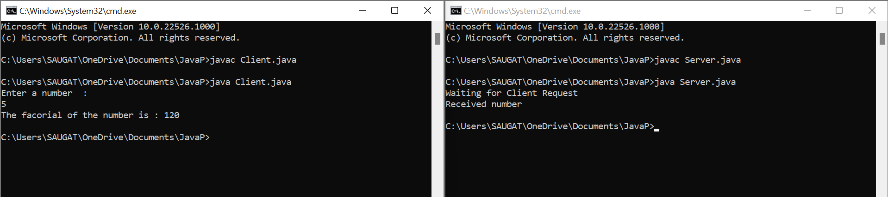**Output:**

**Objective:**

1. **Write a java program using UDP showing that the sending and receiving of message using DatagramPacket and DatagramSocket class.**

**Theory:**

**Java DatagramSocket and DatagramPacket**

Java DatagramSocket and DatagramPacket classes are used for connection-less socket programming using the UDP instead of TCP.

**Datagram**

Datagrams are collection of information sent from one device to another device via the established network. When the datagram is sent to the targeted device, there is no assurance that it will reach to the target device safely and completely. It may get damaged or lost in between. Likewise, the receiving device also never know if the datagram received is damaged or not. The UDP protocol is used to implement the datagrams in Java.

**Java DatagramSocket class**

Java DatagramSocket class represents a connection-less socket for sending and receiving datagram packets. It is a mechanism used for transmitting datagram packets over network. A datagram is basically an information but there is no guarantee of its content, arrival or arrival time.

**Source Code:**

**//sender**

import java.net.DatagramPacket;

import java.net.DatagramSocket;

import java.net.InetAddress;

class Dsender  {

    public static void main(String[] args)throws Exception {

    DatagramSocket ds= new DatagramSocket();

    String str= "Message sent by server";

    InetAddress ip = InetAddress.getLocalHost();

    DatagramPacket dp = new DatagramPacket(str.getBytes(), str.length(),ip, 6666);

    ds.send(dp);

    System.out.println("Message sent!");

    ds.close();

    }

}

**//receiver**

import java.net.DatagramPacket;

import java.net.DatagramSocket;

public class Dreceiver {

    public static void main(String[] args) throws Exception {

        DatagramSocket ds= new DatagramSocket(6666);

        byte[] buf= new byte[1024];

        DatagramPacket dp=new DatagramPacket(buf, 1024);

        ds.receive(dp);

        String str= new String(dp.getData(),0,dp.getLength());

        System.out.println(str);

        System.out.println("Message received!");

        ds.close();

    }

}

**Output:**

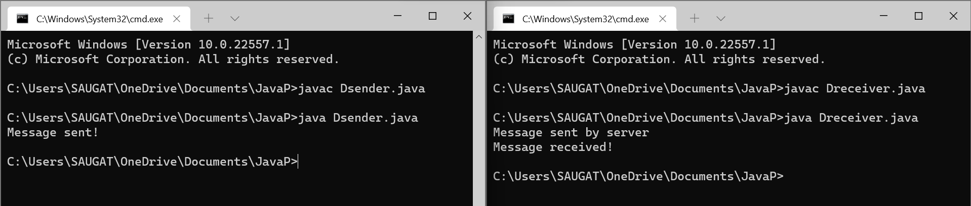

**Conclusion:**

In this lab session, we successfully implement the concepts of Network Programming: TCP/IP and UDP using the java.net package classes in Java programming language.